|  |  |
| --- | --- |
| Nikon AF-S 24-70mm f/2.8E ED VR Nano lens  Ống kính Nikon AF-S 24-70mm f/2.8E ED VR Nano  Nikon AF-S 24-70mm f2.8E ED VR Nano 1 Nikon AF-S 24-70mm f2.8E ED VR Nano 3 Nikon AF-S 24-70mm f2.8E ED VR Nano 5 Nikon AF-S 24-70mm f2.8E ED VR Nano 4 | **Featured information:**  Format: Nikon F-Mount / FX  Aperture: f/2.8 - f/22  Nano Crystal & Super Integrated Coating  ED glass element is aspherical  Price : $ 1900  **Specifications:**  Focal distance  24 - 70mm  Largest Aperture  f/2.8  Smallest Aperture  f/22  Lens Mount  Nikon F  Lens Format  Full-Frame  View  84° - 34°20'  Minimum Focus Distance  38 cm  Magnification  0.27x  Optical Components  20 Elements in 16 Groups  Number of Mouth Blades  9  Focus Type  Autofocus  Anti-Vibratio |

--

**Overview:**

The Nikon AF-S 24-70mm f/2.8E ED VR is a versatile wide-angle to short-angle telephoto lens characterized by a constant f/2.8 maximum aperture and electromagnetic aperture mechanism. Designed for use with FX-format Nikon F-mount cameras, the lens is also compatible with DX models, providing a 36-105mm equivalent focal length range. The fluorine coating on the front and rear parts is resistant to dust and moisture suitable for working in harsh environments.

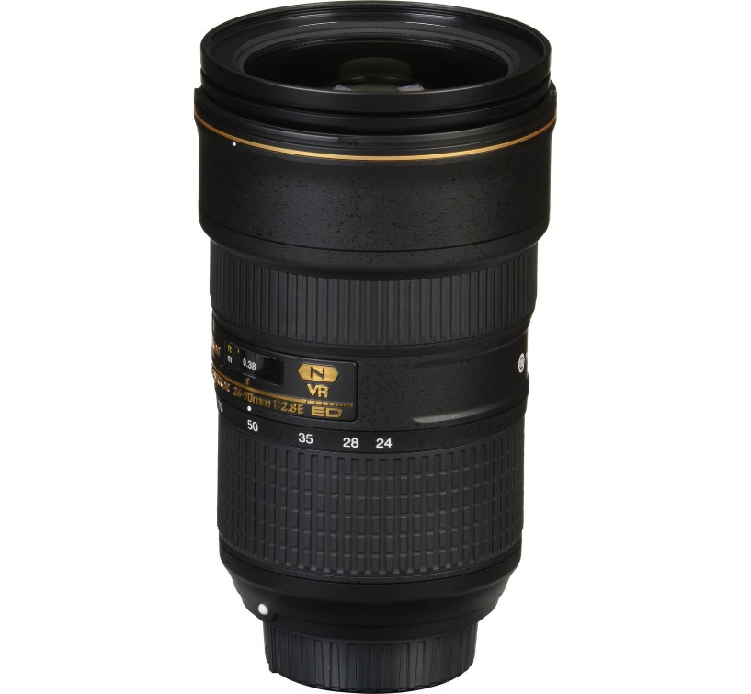

The lens has an optical construction that includes aspherical low dispersion (ASP/ED) lenses combined with traditional aspherical lenses, extra-low dispersion (ED) lenses and high refractive index lenses ( HRI) to reduce chromatic aberrations and distortions for accurate image display. Constant f/2.8 maximum aperture delivers consistent performance throughout the zoom range, advantageous for working in low-light environments. Nano Crystal and Super Integrated Coatings are applied to lens elements to minimize surface and internal reflections to visibly reduce lens flare and vignetting.



Vibration reduction image stabilization reduces the appearance of camera shake by up to four stops to maximize shooting in a variety of lighting conditions.

